WELCOME TO PURRESSENCE PET CARE
It is my mission to positively enhance the busy lives of my clients by providing superior pet care with excellent customer service, trust and security. It’s more than just pet sitting and dog walking – I aim to create peace of mind by ensuring that all pets are being cared for with the exceptional and individualized attention that they deserve, in the comfort of their own home, while you are away. I promise to always conduct myself professionally and with integrity; ensuring that I respect you and your personal property at all times, and to love and treat your pets as though they were our own. I’ll also bring in your mail, newspapers and circulars, water plants, lights on/off and shades up/down because we want your home to look “occupied” when you are away.
Enclosed is your Registration Packet for pet sitting and dog walking services. Please print a copy of this packet and complete all forms prior to your scheduled initial consultation.
This Registration Packet contains:
• Services and Pricing Guide – please initial next to preferred option
• Client Information Form – please fill out in its entirety
• Pet Information Form – please complete one form for each pet in the household
• Key Handling Form – please initial next to preferred option
• Vet Authorization Form – please fill out sign and date
• Service Contract – please sign and date
Please feel free to contact us if you have feedback, questions or concerns. I can be reached by email at Corinne@PurrEssence.com or by calling 860-810-7492

Prices: Every pet is special and PurrEssence will work with you in finding the right service combo that works best for you and your pet(s). Prices include up to two pets. Each additional pet will be charged an additional $5.00 per visit

Express 15 Minute Visit ($15)_______
Standard 30 Minute Visit ($20) ________
Deluxe 1 Hour Visit ($30)__________

How many visits do you want per day? ____________

Payments: Payment is expected no later than 7 days after the final visit. Accept Cards Via the mobile app, cash, or checks. A $30 fee is assessed on all returned checks. All fees are due promptly and must be paid via cash or debit only.
Please Initial: _______

Owner Information
Pet Owners Name (First and Last): _________________________________

Address: ______________________________________________________

Phone Number: ______________________

Email Address: ____________________________________

Emergency Contact: _____________________________________________

Phone number: _________________________________________________

Do you give them permission to care for your pet in the event of an emergency? Initial ________________

Pet’s Information -Please print one pet info sheet per pet.

Name of pet________________________ Type (dog, cat, rabbit etc.) ______________
Breed/Description________________________ Birthday/Age________________
Sex M/ F Spay/Neuter Y/N Estimated Weight _____________
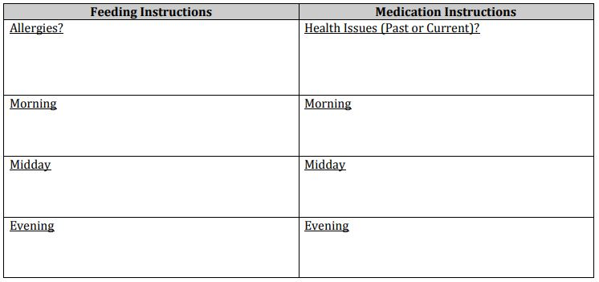
Please describe your pet’s behavior towards new people.

Does your pet know any cues that you would like me to use out on walks? Please describe.

Please describe your pet’s behavior around food and water dishes, toys and bones.

How would you describe your pet’s personality?

Where is your pet’s food, treat, and litterbox (if you have a cat) located?

Where is your pets’ leash, poop bags located (If you have a dog)?

Where is your vacuum, broom and cleaning supplies located?

House entry access
I prefer a lockbox but if one cannot be placed on the house, I have a few other options:

Option one: Lockbox (there is a $5 charge per week or the lockbox can be purchased for $20) _________
Option two: Garage door (hide a key must be placed outside) _________
Option three: Holding on to the key_________

Do you give PurrEssence permission to publish images of your pet(s): _________(Initial)

Any text associated with these images may disclose your pets name, age, species, and breed while also describing certain personality traits

Home security system information

Where is the security system keypad located?

Alarm code + any additional keys to enter before or after the code:

Veterinary Release
If any of my pets appears to be ill, injured, or at significant risk of experiencing a medical problem at the start of service or while in the care of PurrEssence, I give permission to seek veterinary service from a veterinarian or a veterinary clinic. I ask PurrEssence to inform the attending clinic or veterinarian of my requested total diagnosis and treatment limit of $____________ per pet / all pets. I will assume full responsibility for the payment and/or reimbursement for any veterinary services rendered, including but not limited to diagnosis, treatment, grooming, medical supplies, and boarding. I further authorize PurrEssence and my primary veterinarian(s) to share all of the medical records of all of my animals with veterinary clinics in an emergency in the interest of providing the best care for my ill or injured animal(s). I will also make arrangements to guarantee that each animal will remain current on its rabies vaccinations throughout each service period. I agree to notify PurrEssence of any signs of injury or possible illness before any service as soon as the condition appears. PurrEssence reserves the right to cancel service when a pet with a potentially infectious condition exists
This form will be kept on file for all future visits. If anything changes, please let me know ASAP so I can adjust your account.

To the Veterinary Hospital:
PurrEssence has been hired to pet sit for my pet(s) and has my permission to place them in your care in case of an emergency. While PurrEssence will attempt to contact me as soon as medical care is deemed necessary. However, in the event I cannot be reached immediately, I authorize you to treat my pet(s) and will be responsible for the payment of any fees.
Clients Signature: ______________________________________________
Date: ___________________

Policies
-Making a reservation PurrEssence cannot accept time-specific calls as I cannot guarantee specific times accurately (unless the pet is on medications that are time-specific) All visits requests are scheduled within a 2-hour window. By initialing you acknowledge this policy____________
-The client is responsible for providing PurrEssence with updates on any changes regarding your pet's care, health, behavior, and /or any other pertinent information.
-Cancellations must be received 3 hours ahead of the scheduled visit.
-Access to your home by others: If the client allows any other person(s) access to their home during PurrEssence contract period, PurrEssence cannot be held liable for any damages to your property or pets as a result. Please notify PurrEssence if someone will be in your home. Please also notify the person(s) in your home that PurrEssence will be entering your home so that your visitor is not surprised or otherwise upset by my entrance.
-Use of video surveillance: I am honest, trustworthy, and have nothing to hide, and don't mind if you use cameras. Please do not post any videos without my permission.
Emergencies: The client agrees to authorize PurrEssence to handle any emergencies that may arise with their best judgment. PurrEssence will make every effort to contact the client and their emergency contact in the event of an emergency.
Inclement Weather: The service schedule may be changed, interrupted, altered, or canceled at my discretion. Every effort will be made to reach your home safely. If it is not possible to safely drive to your home, your emergency contact will be notified as soon as reasonably possible. It is best your emergency contact is a neighbor so they can reach your home.
Liability Policy:
-I agree to provide services in a reliable and trustworthy manner. The client expressly waives any claims against PurrEssence unless arising from gross negligence on the part of PurrEssence.
-PurrEssence cannot be held responsible for pets that cause damage to furniture, carpet, flooring/woodwork, walls, etc. while the sitter is not present.
-PurrEssence cannot be responsible for any complications pets may suffer or actions of pets while they are unattended.
-If pets exhibit aggressive behavior that poses a risk to me or prohibits me from caring for your pet, service will not be provided.
-Client is responsible for making arrangements for snow removal.

Clients Signature: ______________________________________________
Date: ___________________

